Install Telegram Bot Python Library in Spyder

1. Launch Anaconda Navigator that we have installed previously

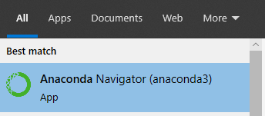

1. Click “Launch” Spyder

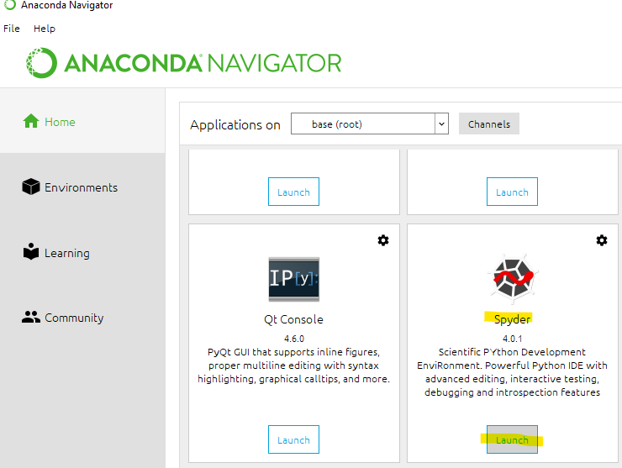

1. If you can see a console like below, go to step 5. If not, go to step 4.

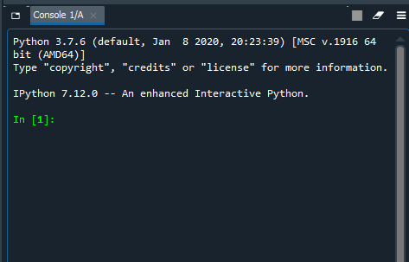

1. If you do not see the console, click on “Consoles” >> “New Console”.

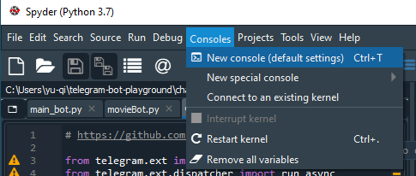

1. Enter “pip install python-telegram-bot” in the console, then press enter

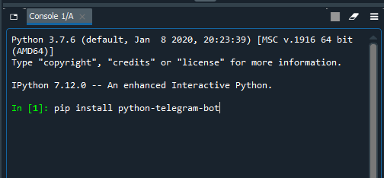

You should see below

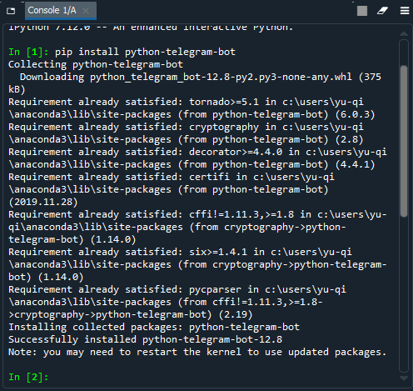

1. Close Spyder and launch it again.
2. Open the python file shared. Click “File” >> “Open” >> browse and open the file you want to open, for example, “main_bot.py”. Note the file should have extension “.py”.

